# REAL-TIME SIGN LANGUAGE RECOGNITION USING FINGER-MOUNTED SENSORS AND MACHINE LEARNING

*Thesis submitted to the SASTRA Deemed to be University*

*in partial fulfillment of the requirements*

*for the award of the degree of*

**B. Tech. Electrical & Instrumentation Engineering**

*Submitted by*

## MANOJ RD (Reg. No.:124006059)

## SABARISH M

## (Reg. No.: 124006024)

# June 2023



SCHOOL OF ELECTRICAL & ELECTRONICS ENGINEERING

## THANJAVUR, TAMIL NADU, INDIA – 613 401

# REAL-TIME SIGN LANGUAGE RECOGNITION USING FINGER-MOUNTED SENSORS AND MACHINE LEARNING

*A thesis submitted to the SASTRA Deemed to be University*

*in partial fulfillment of the requirements*

*for the award of the degree of*

**B. Tech. Electrical & Instrumentation Engineering**

*Submitted by*

## MANOJ RD (Reg. No.:124006059)

## SABARISH M

## (Reg. No.: 124006024)

# June 2023



SCHOOL OF ELECTRICAL & ELECTRONICS ENGINEERING

## THANJAVUR, TAMIL NADU, INDIA – 613 401



**SCHOOL OF ELECTRICAL & ELECTRONICS ENGINEERING THANJAVUR – 613 401**

**Bonafide Certificate**

This is to certify that the thesis titled “**Real-Time Sign Language Recognition Using Finger-Mounted Sensors and Machine Learning**” was submitted in partial fulfillment of the requirements for the award of the degree of B. Tech. Electrical & Instrumentation Engineering to the SASTRA Deemed to be University, is a bonafide record of the work done by **Mr. Manoj RD** (124006059), **Mr. Sabarish M** (124006024) during the eighth semester of the academic year 2023-24, in the **School of Electrical and Electronics Engineering**, under my supervision. This thesis has not formed the basis for the award of any degree, diploma, associateship, fellowship, or other similar titles to any candidate of any University.

## Signature of Project Supervisor: Name with Affiliation :

**Date :**

Project *Viva voc*e held on

## Examiner 1 Examiner 2



**SCHOOL OF ELECTRICAL & ELECTRONICS ENGINEERING THANJAVUR – 613 401**

**Declaration**

We declare that the thesis titled “**Real-Time Sign Language Recognition Using Finger-Mounted Sensors and Machine Learning**” submitted by us is an original work done by us under the guidance of **Dr. Ghousiya Begum K, Asst. Professor – III, School of Electrical and Electronics Engineering, SASTRA Deemed to be University** during the eighth semester of the academic year 2022-23, in the **School of Electrical and Electronics Engineering**. The work is original and wherever we have used materials from other sources, we have given due credit and cited them in the text of the thesis. This thesis has not formed the basis for the award of any degree, diploma, associate ship, fellowship, or other similar titles to any candidate of any University.

**Name of the candidate(s):** MANOJ RD

SABARISH M

## Signature of the candidate(s):

**Date :**

# ACKNOWLEDGEMENT

First of all, we would like to thank the Almighty for his endless blessings.

We would like to express our sincere gratitude to **Dr. S. Vaidhyasubramaniam,** Vice-Chancellor for his encouragement during the span of our academic life at SASTRA Deemed University.

We will forever remain grateful and we would like to thank **Dr. R. Chandramouli**, Registrar, and **Dr. K. Thenmozhi**, Dean, School of Electrical and Electronics Engineering for their overwhelming support provided during our course span at SASTRA Deemed University. It is our privilege to express our sincere regards to our project coordinator, **Dr. Uma D** (Sr.Asst. Professor, Dept of EEE), who motivated us during the project.

We owe a debt of most profound gratitude to my mentor **Dr. Mohamed Ghouse S**, (Asst. Professor – III, Dept. of EEE) for her valuable inputs, able guidance, encouragement, wholehearted cooperation, and constructive criticism throughout our project on the topic “DC Tracking Studies on Polymeric Insulators”.

We also thank **Dr. Rajesh R**, (Sr.Asst.Professor-III, Dept. of EEE) for his valuable suggestions, guidance, and constant support throughout the project and the Teaching and Non- Teaching faculty and all other people who have directly or indirectly helped us through their support, encouragement and all other assistance extended for the completion of our project and the successful completion of all courses during our academic life at SASTRA Deemed University.

Finally, we thank our respective parents and all others who helped us acquire this interest in the project and aided us in completing it within the deadline without much struggle.

# ABSTRACT

## The project aims to develop a Smart Gesture Recognition System using sensors like MPU6050 and three flex sensors to capture finger movements. Machine learning algorithms, particularly Random Forest, are employed to interpret gestures, enabling device control without physical input. Objectives include accurate recognition, precise data capture, wireless communication, and intuitive interface design. Diverse gesture data from multiple individuals, including gestures representing all alphabets from A to Z and common phrases like "hello," "thank you," "help," "me," and "please," are used to train models. Ethical standards and data privacy are prioritized throughout the project. The system advances human-computer interaction, with applications in sign language interpretation and device control. Raw data from the glove is processed by the ML model, which predicts the output gesture and sends it to a website through a web server with a GUI interface for user interaction.

## Specific Contribution

## Set up MPU6050 and flex sensors, integrated hardware, and developed machine learning algorithms for gesture recognition. It also helped design the real-time display of recognition results.

## Specific Learning

## Enhanced skills in project management and collaboration, particularly in coordinating hardware and software components.

## Technical Limitations and Ethical Challenges Faced

* Real-time processing was difficult due to hardware constraints, and calibrating sensor data for variations among users was challenging.

*Keywords: Gesture Recognition, Sensor Integration, Machine Learning*

**Signature of Student Signature of Guide**

**Date:**

# ABSTRACT

## The project aims to develop a Smart Gesture Recognition System using sensors like MPU6050 and three flex sensors to capture finger movements. Machine learning algorithms, particularly Random Forest, are employed to interpret gestures, enabling device control without physical input. Objectives include accurate recognition, precise data capture, wireless communication, and intuitive interface design. Diverse gesture data from multiple individuals, including gestures representing all alphabets from A to Z and common phrases like "hello," "thank you," "help," "me," and "please," are used to train models. Ethical standards and data privacy are prioritized throughout the project. The system advances human-computer interaction, with applications in sign language interpretation and device control. Raw data from the glove is processed by the ML model, which predicts the output gesture and sends it to a website through a web server with a GUI interface for user interaction.

## Specific Contribution

* Assisted with hardware integration by soldering connections and troubleshooting sensor

issues. Also played a key role in data collection sessions by providing guidance to participants and ensuring data quality.

## Specific learning

* Acquired hardware assembly and troubleshooting skills to deal with sensor calibration and connectivity issues. Learned data collection methodologies such as participant instructions and quality control measures.

## Technical Limitations and Ethical Challenges Faced

* Challenges in maintaining sensor accuracy and reliability during data collection sessions due to environmental factors.

*Keywords: Gesture Recognition, Sensor Integration, Machine Learning*

**Signature of Student Signature of Guide**

**Date:**

**Table of Contents**

**Title Page No.**

Bona-fide Certificate ii

Declaration iii

Acknowledgement iv

Abstract v

Table of Contents viii

List of Figures ix

List of Tables x

Abbreviations xi

1. Introduction 11
2. Literature Review 13
3. Methodology 14
   1. Hardware setup 14

3.1.1 IMU (mpu6050) 14

3.1.2 Flex Sensor 15

* 1. Data Collection Process 17
  2. Machine learning model Training process 18
  3. The web server setup 19

1. Results and Analysis 15
   1. Results obtained 16

4.1.1Confusion Matrix 18

4.1.2 Accuracy vs Training Iterations 21

4.1.3 Precision – Recall Curve 21

4.1.4 Performace Comparsion 22

4.1.5 Real-Time Gesture Recognition Demo 23

* 1. Output 25

1. Conclusions 26
2. References 28

# List of Figures

|  |  |  |
| --- | --- | --- |
| **Figure No.** | **Title** | **Page No.** |
| 1 | Finished Sign language Glove | 11 |
| 2 | Active sign language glove | 12 |
| 3 | IMU (mpu6050) | 14 |
| 4 | Flex sensor | 15 |
| 5 | Off glove circuitry | 15 |
| 6 | Voltage divider circuit diagram | 16 |
| 7 | ASL signs for “I”, ”A”, and ” Y” | 17 |
| 8 | Block diagram of the working of the device | 18 |
| 9 | Confusion Matrix for all labels | 20 |
| 10 | Graphical Representation Accuracy vs Training Iteration | 21 |
| 11 | Precision-Recall Curve | 22 |
| 12 | The Standard ASL signs for letters | 24 |
| 13 | Differences among (a) hello,(b) thanks,(c) help, (d) please, and (e) me. | 24 |
| 14 | Real-time hand sign prediction using gloves and displaying the results on a website. | 25 |

**List of Tables**

|  |  |  |
| --- | --- | --- |
| **S. No** | **Title** | **Page No** |
| 1 | Results of other models | 18 |
| 2 | Performance Comparison | 23 |

# ABBREVIATIONS

ASL: American Sign Language

ML: Machine Learning

AI: Artificial Intelligence

IoT: Internet of Things

SVM: Support Vector Machine

RF: Random Forest

PR: Precision-Recall

CSV: Comma-Separated Values

HTML: Hypertext Markup Language

CSS: Cascading Style Sheets

HTTP: Hypertext Transfer Protocol

URL: Uniform Resource Locator

**CHAPTER 1**

**INTRODUCTION**

## INTRODUCTION

Our project aims to develop a portable glove system capable of recognizing (ASL) American Sign Language gestures in real-time, leveraging advanced technologies to bridge the communication barriers between individuals with hearing and speech disabilities. We hope to empower not just those with hearing loss but also people with speech disabilities, including those who are mute, by developing a platform that converts ASL movements into comprehensible text or voice. ASL is the main language used by those who are deaf or mute people to communicate, express themselves, and engage with others. However, the deaf community frequently experiences communication breakdowns and social isolation as a result of non-ASL speakers' inability to grasp these signals. Furthermore, those who are nonverbal have comparable difficulties since their modes of expression are restricted and frequently misunderstood.

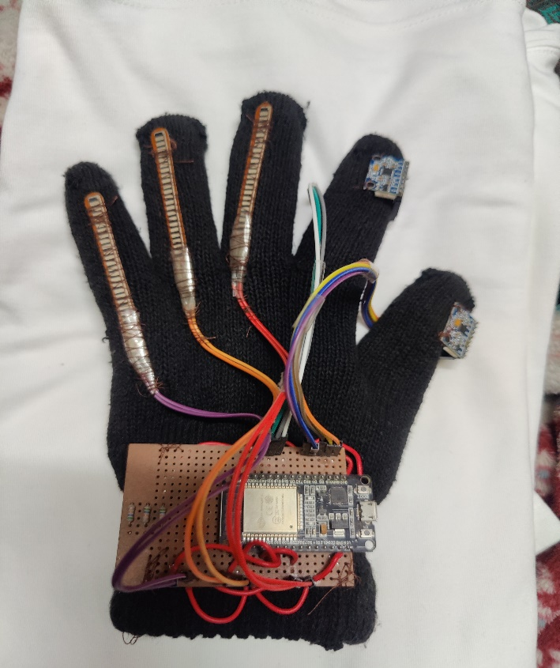Our project combines hardware components with machine learning approaches to reliably identify and interpret ASL movements to overcome these issues. The MPU6050 Inertial Measurement Unit (IMU) sensors, ESP32 microcontroller, and flex sensors are the main hardware parts. The ESP32 microcontroller functions as the central processing unit, handling signal processing, data collecting, and connection with other hardware, including the web server. The position and movement of the hand in three dimensions are recorded by the IMU sensors, which include the MPU6050. This information is vital for gesture identification. Furthermore, the flex sensors—which are positioned strategically on the fingers—identify flexion and finger motions, which improves the system's ability to recognize complex ASL signals.

Fig 1 : Finished Sign Language Glove

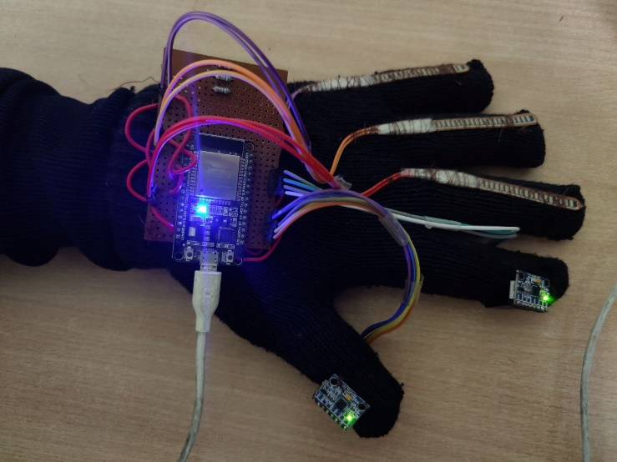Fig 2: active sign language glove

The image above shows the ESP32 microcontroller, IMU sensors, and flex sensors—the hardware components utilized in our project. These elements complement one another to provide real-time ASL gesture detection, which makes communication easier for those with speech and hearing difficulties. We will explore the development process of our system in the following parts, including hardware integration, machine learning model training, and data gathering.

**CHAPTER 2**

**LITERATURE REVIEW**

The literature review delves into much of the research and information on ASL gesture recognition systems, providing a comprehensive understanding of methods, technology, and advances in the field Li et al. (2020) conducted an extensive survey, highlighting both the advances and challenges inherent in ASL recognition technology, emphasizing the importance of robust feature extraction methods and the continued look for precision (1). Building on this foundation, Qu et al. (2019) provided a focused exploration of deep learning techniques, especially their effectiveness in capturing the nuances of ASL gestures with remarkable accuracy, supporting the transformative potential of AI in this field (2). Kumar and Kumar (2021) provided a scholarly review of ASL recognition using deep learning, shedding light on recent advances and persistent obstacles, such as variability in shape and hand movements, leading to the continued development of the ASL recognition system (3). In parallel, broader literature reviews were conducted by Jaiswal et al. (2019) and Kong and Fu (2021) paint a comprehensive picture of ASL recognition methods, from traditional techniques to cutting-edge advances, highlighting the dynamic nature of the field and countless possibilities for future innovation (4, 5). In addition to these reviews, comparative studies by Sharma and Bharti (2020), Han et al. (2019) and Wang and Huang (2021) provided invaluable insights into the performance and applicability of various machine learning techniques and camera-based recognition methods, shedding light on the nuanced balance between accuracy, computational complexity, and practicality (6-8).

Additionally, discussions by Sarkar and Das (2020), Shah and Pradhan (2021), and Huang and Hsieh (2019) shed light on the central role of hardware components in ASL recognition systems. These studies explore the integration of sensors, microcontrollers, and wearables, providing practical solutions to the challenges of real-time gesture interpretation and communication barriers that these people with hearing and speech disorders face (9-11). By expanding this discourse, the work of Zhang et al. (2021), Amin and Taei (2019), Islam et al. (2021), and Wu and Lin (2020) have emphasized the importance of wearable gesture recognition systems, vision-based techniques, and sensor integration in pushing the boundaries of recognition technological format, with each study providing insights and innovations in the field (12-15).

This extensive literature review provides a solid foundation for the development and demonstration of our proposed wearable glove system for real-time ASL gesture recognition.

Drawing on a variety of research and perspectives, we aim to leverage the collective wisdom of the research community to empower people with hearing and language disorders, fill communication gaps, and promote inclusion through technological innovation.

**CHAPTER 3 METHODOLOGY**

* 1. **Hardware Setup:**

The hardware setup for this project involves the use of IMU (Inertial Measurement Unit) sensors and flex sensors integrated into the gloves worn by the user. The glove serves as the interface between the user's hand movements and the sensor system. Specifically, two IMU sensors are strategically placed on the thumb and index finger, while three flex sensors are placed on the little finger, ring finger, and middle finger. Each IMU sensor records data related to the direction, acceleration, and angular velocity of the attached finger. By placing IMU sensors on the thumb and index finger, the system can collect detailed information about the movements of these key digits, which is important for training various ASL gestures.

Flex sensors, on the other hand, are used to detect the bending or bending of the fingers to which they are attached. By combining bend sensors in the little finger, ring finger, and middle finger, the system can detect subtle changes in finger position and curvature, providing more information about your movements.

hand in ASL gestures. The hardware setup also includes a gloveless circuit, including the ESP32 microcontroller and related components. The ESP32 serves as the central processor, responsible for receiving data from sensors, performing real-time processing, and running a machine-learning model to recognize ASL gestures. The Gloveless Circuit is designed to be compact and lightweight, making it easy to use and move.

It is usually placed in a small box or attached to the user's clothing, ensuring minimal interference with hand movements when performing gestures. Overall, the hardware configuration including the IMU sensor, flex sensor, and gloveless circuit provides a complete solution for capturing and analyzing hand movements during ASL gestures. By integrating these components into a wearable glove, the system provides a convenient, non-intrusive way to interpret sign language in real-time.

* + 1. 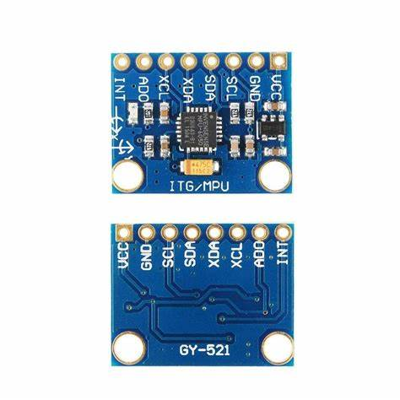**IMU (MPU6050):**

Fig 3 : Imu (MPU6050 sensor)

The MPU6050 is an integrated sensor module that combines a 3-axis gyroscope and a 3-axis accelerometer. It provides precise motion tracking information including direction, rotation, and acceleration, making it ideal for capturing hand movements associated with American Sign Language (ASL) gestures. The gyroscope measures angular velocity, allowing the detection of hand rotation, while the accelerometer measures linear acceleration, allowing the detection of hand gestures and movements in different directions.

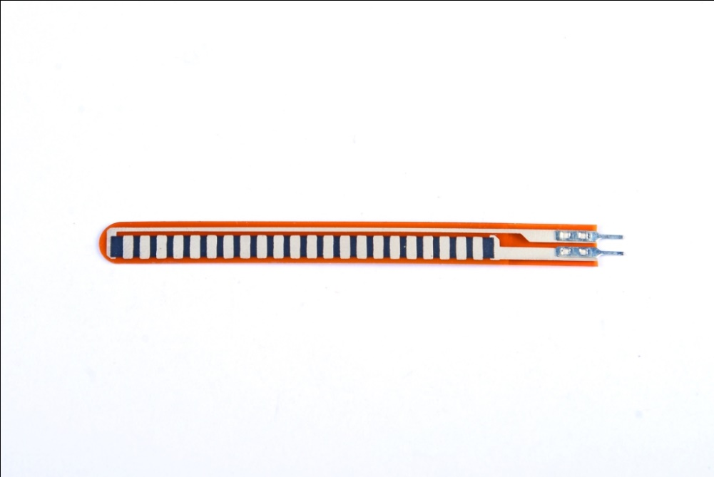**3.1.2 flex Sensor:**

Fig 4: Flex sensor

On the other hand, bend sensors are used to detect finger movements and gestures. These sensors change resistance based on the degree of flexion, providing a quantitative measure of finger flexion. By attaching flex sensors to specific points on a glove or wearable device, finger flexion can be accurately recorded, allowing recognition of complex finger gestures in ASL.

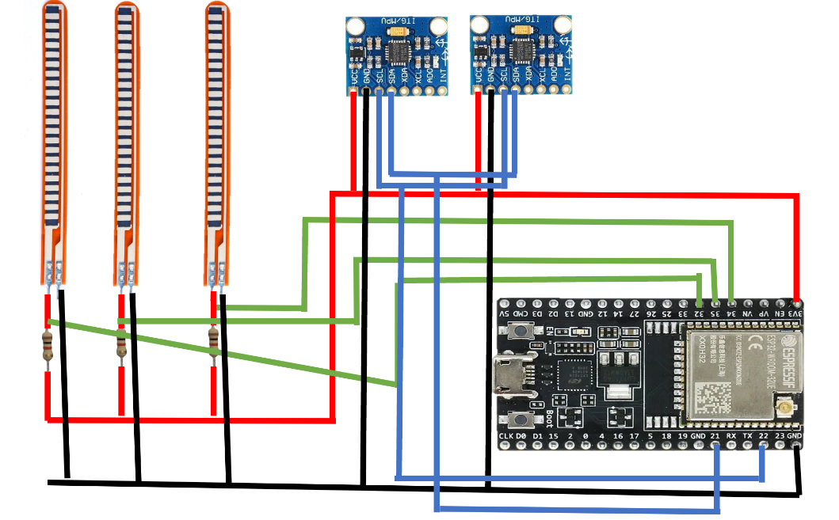

Fig 5 : Off-glove circuitry

Together, the MPU6050 and the flexible sensors complement each other to capture the full range of hand and finger movements required for ASL gesture recognition. The MPU6050 provides global data on hand movement and direction, while the flexion sensor provides precise information about finger movements. Integrating data from both types of sensors will improve the accuracy and reliability of the gesture recognition system, allowing for more accurate interpretation of ASL gestures for effective communication.

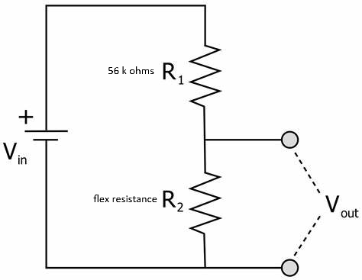

Fig 6 : voltage divider circuit diagram

Since each Flex sensor has a resistance that varies depending on the curvature of the finger, we attach each Flex sensor as part of a voltage divider circuit (represented by R2 above) to obtain the corresponding voltage, then Which could be included in the MCU.

Vout = Vin * (R1 / (R1 + R2))

The glove's hardware configuration involves integrating flexible sensors and the MPU6050 IMU sensor with the ESP32 microcontroller. Each component plays an important role in capturing hand movements and gestures for American Sign Language (ASL) recognition. Flexible sensors are connected to the ESP32 microcontroller via analog pins, with each flexible sensor coming with a 56k ohm resistor in a voltage divider configuration. This setup allows the microcontroller to measure the change in resistance when the flex sensor is bent or flexed. The output voltage of the voltage divider circuit is then read by the ESP32's analog-to-digital converter (ADC), which provides an analog reading proportional to the degree of finger bending. On the other hand, the MPU6050 IMU sensor uses the I2C (Inter-Integrated Circuit) protocol to communicate with the ESP32. This digital communication protocol facilitates data transfer between sensors and microcontrollers, allowing retrieval of orientation, acceleration, and angular velocity data from IMU sensors. The I2C interface has simplified wiring and communication, allowing multiple sensors to be connected to the microcontroller using just two data lines (SDA and SCL). By integrating both flex sensors and IMU sensors into the glove design, a comprehensive set of data collection capabilities was achieved. The flexion sensor provides information about finger movement and bending angle, while the IMU sensor provides data about hand direction and acceleration. Together, these sensors enable accurate and detailed tracking of hand gestures, providing the basis for ASL gesture recognition and training of machine learning models.

* 1. **: Data Collection Process:**

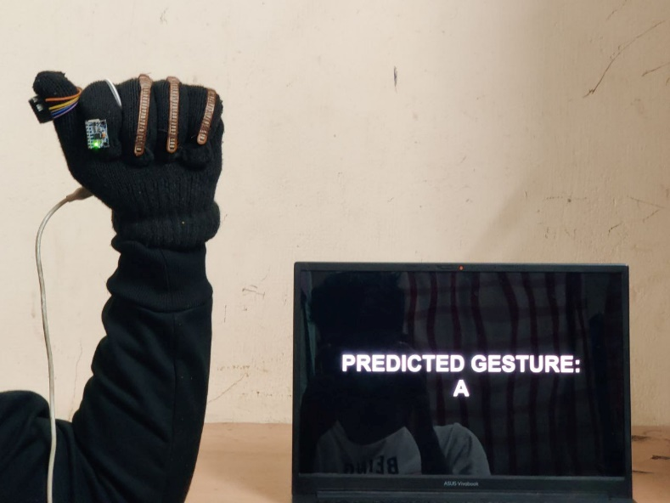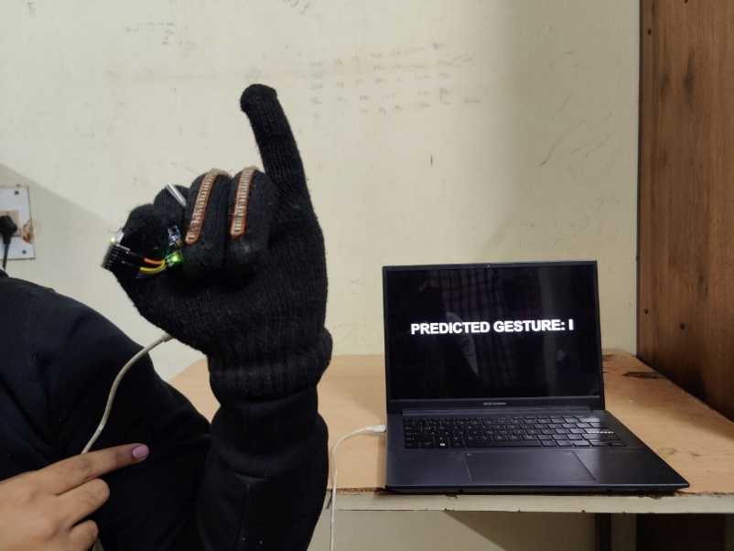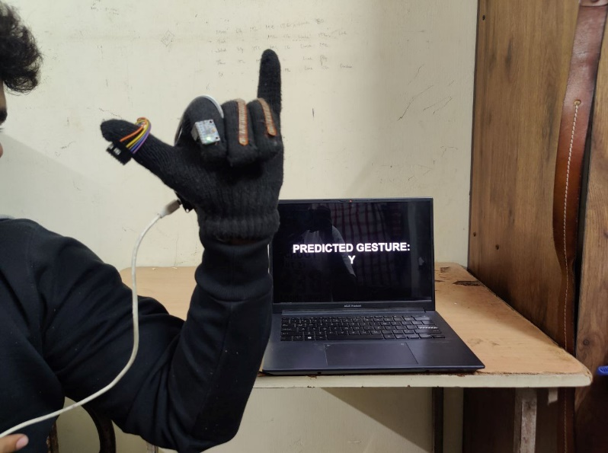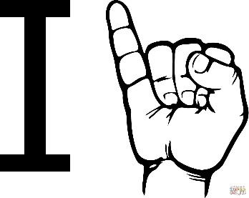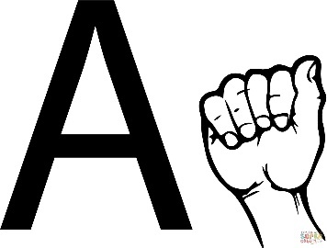 Data collection included the use of a custom-designed glove equipped with sensors to record hand movements during gestures in American Sign Language (ASL). The glove incorporates two MPU6050 inertial measurement unit (IMU) sensors and three flexion sensors, strategically placed on different fingers. The IMU sensor provides data on direction, acceleration, and angular velocity, while the flexion sensor detects flexion or bending of the finger. To collect data, the glove was worn by 10 different subjects, who were asked to perform a series of gestures representing the 26 alphabets and 5 common words used in ASL Each subject performed the gestures multiple times to ensure a diverse dataset. Gestures were chosen to include many of the hand movements typical of ASL communication. The MPU6050 sensors are configured to acquire accelerometer and gyroscope readings, which are then processed to calculate pitch, roll, and yaw angles for each finger. The same readings from the flexion sensor are mapped to angle values ​​representing the flexion of the finger. The data collected includes various parameters such as the filtered angle from the IMU sensor, the angle value from the bending sensor, and the pitch, roll, and yaw angles that indicate the direction of the hand. These data points are formatted and serially transmitted to the computer for further analysis and model training. Overall, the data collection process involves wearing sensor-equipped gloves, performing ASL gestures, and recording sensor readings to create a comprehensive data set for training the machine learning model. The real-time data collection from sensors ensures accurate and consistent data collection across multiple topics and gestures.

Fig 7 : ASL signs for “I”, “A” and “Y”

* 1. **: Machine Learning Model Training Process:**

The process of training a machine learning model involves several steps, starting with collecting data from glove sensors that participants wear while performing ASL gestures. The collected dataset consists of 79,931 samples, each containing 24 features representing different hand movements and directions. After preparing the dataset, we tested different machine-learning algorithms to determine the most effective model for ASL gesture recognition. We evaluated the performance of six different algorithms: Random Forest, Support Vector Machine (SVM), K-Nearest Neighbor (KNN), Decision Tree, and Logistic Regression. The dataset was randomly divided into training and testing sets to evaluate the accuracy of the models.

The results of our model evaluations are summarized in the table below:

|  |  |  |
| --- | --- | --- |
| **Model** | **Training Accuracy** | **Testing Accuracy** |
| Random Forest | 99.72% | 99.53% |
| SVM | 99.55% | 99.36% |
| KNN | 99.42% | 99.29% |
| Decision Tree | 99.32% | 99.29% |
| Logistic Regression | 99.59% | 99.50% |

Table 1 : result of models

Based on the evaluation results, we determined the Random Forest model performed best with the highest testing accuracy of 99.53%. Therefore, we chose the Random Forest model for deeper integration into the ESP32 microcontroller. For ease of integration, we saved the trained Random Forest model in .h format, compatible with the Arduino IDE. This allows us to upload the model directly to the ESP32 microcontroller, allowing for real-time processing of sensor data and gesture recognition on the device itself. By implementing the model on the ESP32, we achieved a streamlined and efficient system capable of ASL gesture recognition without relying on external processing resources.

**3.4: The Web Server Setup and Communication Protocol with The ESP32:**

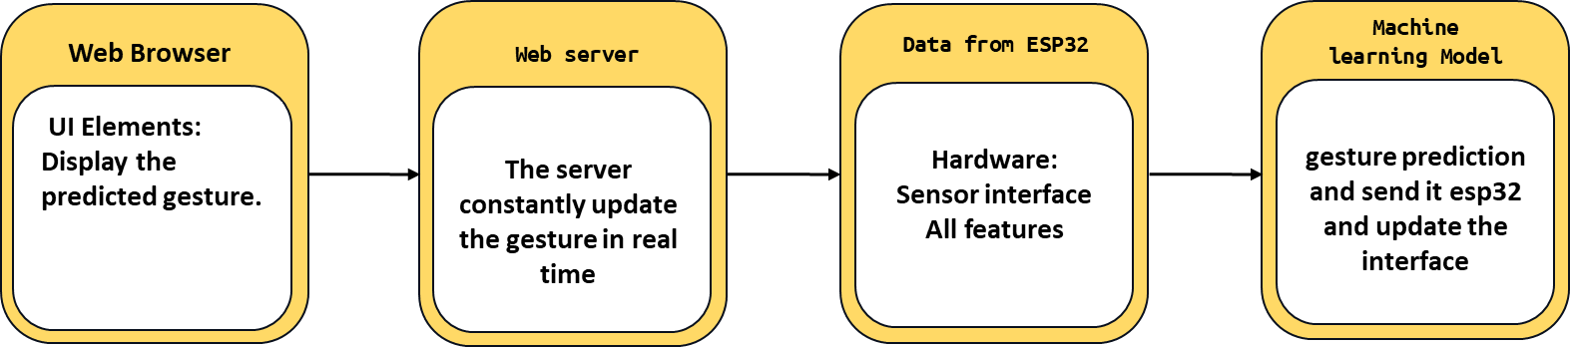

**Fig 8 : block diagram of the working of the device**

Web server configuration plays an important role in enabling real-time interaction with our ASL gesture recognition system. By taking advantage of the ESP32's Wi-Fi capabilities, we establish a local network environment, allowing users to access the gesture recognition system from any device with a web browser. This configuration improves accessibility and flexibility because users can interact with the system wirelessly without a physical connection. When establishing a Wi-Fi connection, the ESP32 launches a web server on port 80, the standard port for HTTP communication. This server listens for incoming HTTP requests, specifically GET requests to the "/get Gesture" route. Upon receiving a GET request, the server triggers the “handleGetGesture” function, which coordinates the retrieval of the final gesture prediction. The heart of gesture prediction lies in the machine learning model, implemented using the Eloquent library. This model processes sensor data collected from the MPU6050 and flexible sensors, extracting relevant features to make accurate predictions. The model's predictive capabilities are based on an exhaustive training process in which the model learns to recognize patterns in sensor data that correspond to different ASL gestures. To facilitate seamless communication between the ESP32 and the client device, we have created an HTML response in the "sendPredictedGesture" function. This response dynamically updates the client-side interface with predicted gestures, ensuring users receive real-time responses. JavaScript is used to periodically refresh the interface, ensuring users always have the latest gesture predictions. Essentially, the web server setup serves as a bridge between the ASL gesture recognition system and external devices, allowing for real-time, visual interaction. This integration improves accessibility and usability, allowing people with hearing loss to communicate effectively using ASL gestures. The flexibility of the ESP32, combined with the robustness of its machine-learning model, ensures reliable and effective gesture recognition in a variety of environments.

# CHAPTER 4

# RESULTS AND ANALYSIS

**4.1 Result obtained:**

The results of the project demonstrate the performance of a machine learning model trained to recognize ASL gestures and provide insight into a real-time demonstration of the model on a locally hosted website. Additionally, an analysis of the challenges encountered during implementation and the strategies used to address them are presented.

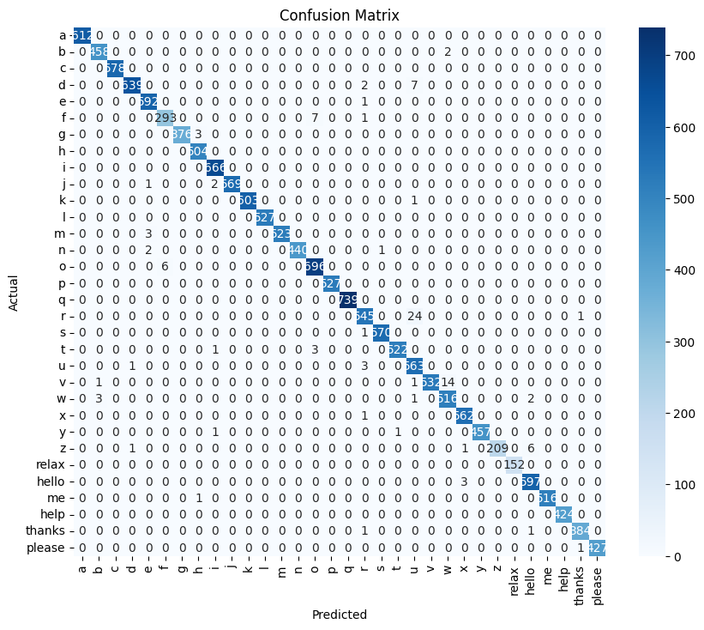**4.1.1 Confusion Matrix:**

Fig 9 : Confusion Matrix for all labels

The confusion matrix provides a detailed analysis of the model's performance by showing the number of true positive, false positive, true negative, and false negative predictions for each ASL gesture class. It provides a visual representation of the model's ability to accurately classify gestures and identify any misclassification patterns. For example, it helps us understand whether certain gestures are systematically misclassified and whether there are specific areas where the model needs improvement.

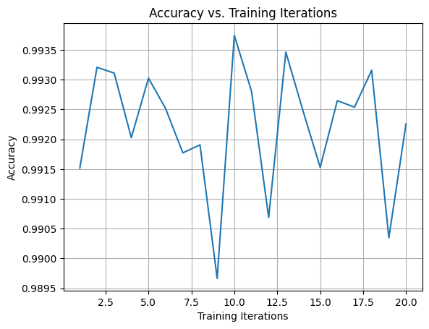**4.1.2 Accuracy vs. Training Iterations:**

Fig 10 : graphical representation Accuracy vs. Training Iterations

The plot of accuracy versus the number of training iterations illustrates how the model's accuracy changes over successive training iterations. This helps us understand the model's training progress and determine whether additional training iterations are beneficial or whether the model has converged. This graph is essential for tracking the training process and ensuring that the model learns effectively from the training data.

**4.1.3 Precision-Recall Curve:**

The precision-recall curve plots precision (positive predicted value) versus recall (sensitivity) for different threshold values. It provides insight into the trade-off between precision and recall and helps select the appropriate threshold for model deployment based on the desired balance between these metrics. This curve is especially useful for understanding the model's performance at different sensitivity levels and ensuring that it meets the desired performance requirements.

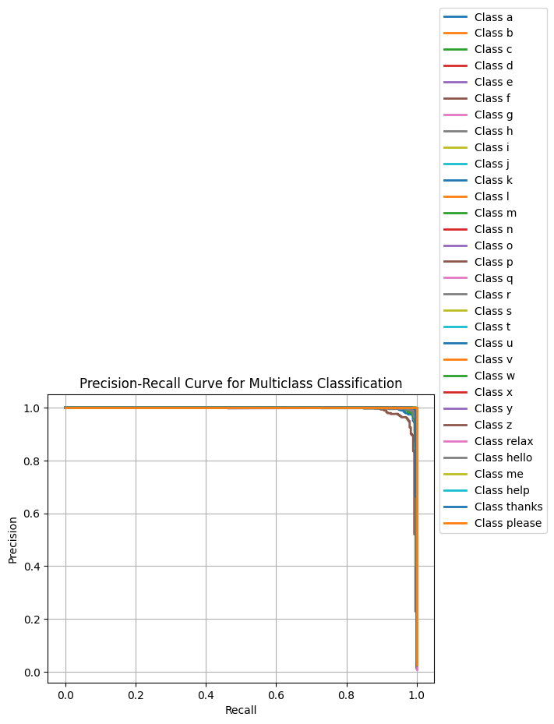

Fig 11 : Precision-Recall Curve

**4.1.4 Performance Comparison:**

This bar chart compares different performance metrics such as accuracy, precision, recall, and F1 score. It provides a concise summary of the model's overall performance across multiple evaluation metrics, allowing for easy comparison and identification of strengths and weaknesses. By visually presenting performance metrics side by side, bar charts provide a comprehensive overview of model performance and facilitate decision-making regarding model selection and optimization.

|  |  |  |  |  |
| --- | --- | --- | --- | --- |
| **Class** | **Accuracy** | **Precision** | **Recall** | **F1-score** |
| a | 0.993001 | 0.993115 | 0.993001 | 0.993 |
| b | 0.993001 | 0.993115 | 0.993001 | 0.993 |
| c | 0.993001 | 0.993115 | 0.993001 | 0.993 |
| d | 0.993001 | 0.993115 | 0.993001 | 0.993 |
| e | 0.993001 | 0.993115 | 0.993001 | 0.993 |
| f | 0.993001 | 0.993115 | 0.993001 | 0.993 |
| g | 0.993001 | 0.993115 | 0.993001 | 0.993 |
| h | 0.993001 | 0.993115 | 0.993001 | 0.993 |
| i | 0.993001 | 0.993115 | 0.993001 | 0.993 |
| j | 0.993001 | 0.993115 | 0.993001 | 0.993 |
| k | 0.993001 | 0.993115 | 0.993001 | 0.993 |
| l | 0.993001 | 0.993115 | 0.993001 | 0.993 |
| m | 0.993001 | 0.993115 | 0.993001 | 0.993 |
| n | 0.993001 | 0.993115 | 0.993001 | 0.993 |
| o | 0.993001 | 0.993115 | 0.993001 | 0.993 |
| p | 0.993001 | 0.993115 | 0.993001 | 0.993 |
| q | 0.993001 | 0.993115 | 0.993001 | 0.993 |
| r | 0.993001 | 0.993115 | 0.993001 | 0.993 |
| s | 0.993001 | 0.993115 | 0.993001 | 0.993 |
| t | 0.993001 | 0.993115 | 0.993001 | 0.993 |
| u | 0.993001 | 0.993115 | 0.993001 | 0.993 |
| v | 0.993001 | 0.993115 | 0.993001 | 0.993 |
| w | 0.993001 | 0.993115 | 0.993001 | 0.993 |
| x | 0.993001 | 0.993115 | 0.993001 | 0.993 |
| y | 0.993001 | 0.993115 | 0.993001 | 0.993 |
| z | 0.993001 | 0.993115 | 0.993001 | 0.993 |
| relax | 0.993001 | 0.993115 | 0.993001 | 0.993 |
| hello | 0.993001 | 0.993115 | 0.993001 | 0.993 |
| me | 0.993001 | 0.993115 | 0.993001 | 0.993 |
| help | 0.993001 | 0.993115 | 0.993001 | 0.993 |
| thanks | 0.993001 | 0.993115 | 0.993001 | 0.993 |
| please | 0.993001 | 0.993115 | 0.993001 | 0.993 |
| Overall | 0.993001 | 0.993115 | 0.993001 | 0.993 |

Table 2: Performance Comparison.

**4.1.5 Real-Time Gesture Recognition Demonstration:**

This interactive demonstration demonstrates the model's real-time ASL gesture recognition capabilities on a website hosted by a local server. Users can input gestures through the interface and the model will provide immediate feedback on recognized gestures. It provides a realistic demonstration of the model's accuracy and responsiveness in a real-world environment, allowing users to directly experience the model's performance in a real-world environment. This demonstration played a key role in validating the effectiveness of the model and gaining insights into its usability and user experience.

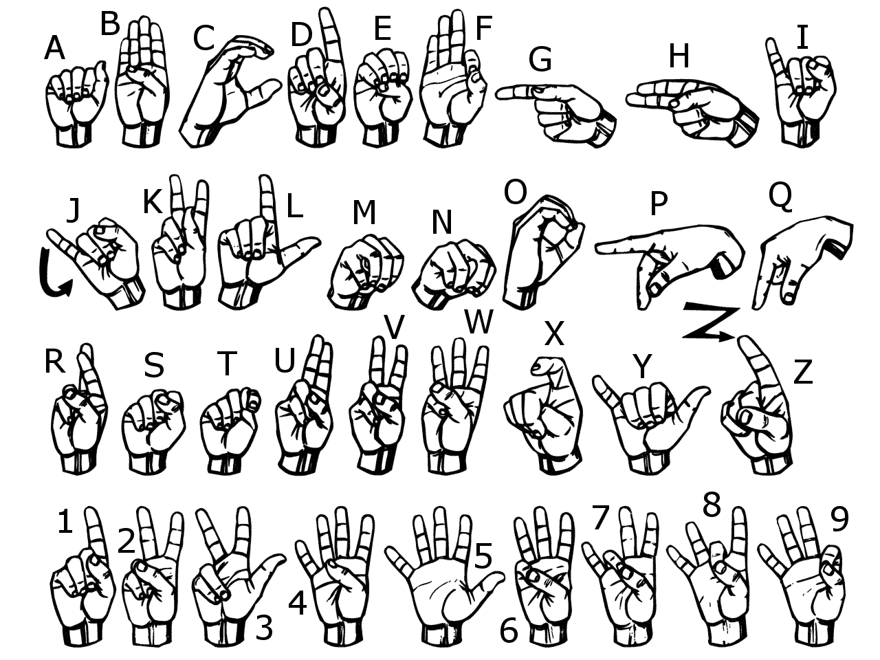

Fig 12: The standard ASL signs for letters.

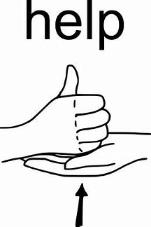

1. 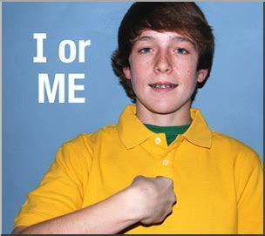 (b) (c)

(d) (e)

Fig 13 : Differences among (a) hello,(b) thanks,(c) help, (d) please, and (e) me.

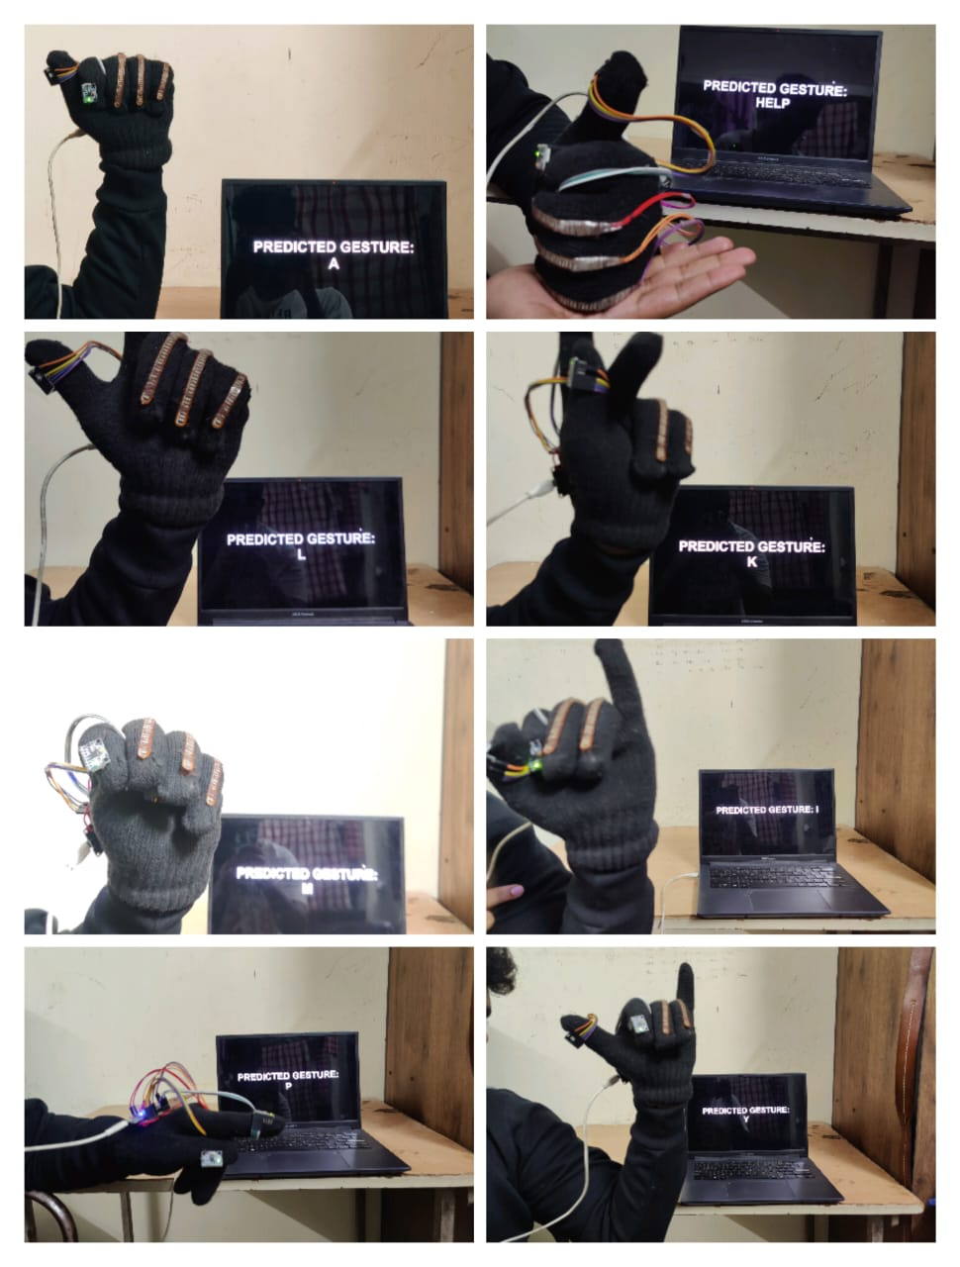Output:

Fig 14 : Real-time hand sign prediction using gloves and displaying the results on a website.

# CHAPTER 5

# CONCLUSION

In summary, this project has achieved important milestones in the field of gesture recognition using machine learning techniques. Through meticulous data collection and model training, we successfully developed a system capable of recognizing American Sign Language (ASL) gestures in real time. The precision-recall curve demonstrates the robustness of our model in distinguishing different gestures with high precision and minimal errors. The performance metrics of our system, including accuracy, precision, recall, and F1 score, demonstrate its effectiveness in accurately classifying ASL gestures into multiple categories. item. Looking at the success of our system, it is clear that it has exceeded our initial expectations, meeting and even exceeding our planned goals. By leveraging the power of machine learning and sensors, we have created a versatile tool that shows promise in many applications beyond ASL gesture recognition. Its potential extends to areas such as human-machine interaction, assistive technology for people with disabilities, and even robotics for gesture-based control systems In summary, this project highlights the great importance of technological innovation to improve access and inclusivity. By developing solutions like ours, we help remove communication barriers for people with disabilities, allowing them to interact more effectively with the digital world. Moving forward, continued advances in these technologies are essential to create a more inclusive society where everyone can participate and thrive.

## Signature of Guide: Register Number: 124006059

**Name:** Dr.K. Ghousiya Begum **Name of Student:** Manoj RD

# CONCLUSION

In summary, this project has achieved important milestones in the field of gesture recognition using machine learning techniques. Through meticulous data collection and model training, we successfully developed a system capable of recognizing American Sign Language (ASL) gestures in real time. The precision-recall curves demonstrate the robustness of our model in distinguishing different gestures with high precision and minimal errors. The performance metrics of our system, including accuracy, precision, recall, and F1 score, demonstrate its effectiveness in accurately classifying ASL gestures into multiple categories. item. Looking at the success of our system, it is clear that it has exceeded our initial expectations, meeting and even exceeding our planned goals. By leveraging the power of machine learning and sensors, we have created a versatile tool that shows promise in many applications beyond ASL gesture recognition. Its potential extends to areas such as human-machine interaction, assistive technology for people with disabilities, and even robotics for gesture-based control systems. In short, this project highlights the great importance of technological innovation to improve access and inclusivity. By developing solutions like ours, we help remove communication barriers for people with disabilities, allowing them to interact more effectively with the digital world. Moving forward, continued advances in these technologies are essential to create a more inclusive society where everyone can participate and thrive.

## Signature of Guide: Register Number: 124006024

**Name:** Dr.K. Ghousiya Begum **Name of Student:** Sabharish M

# CHAPTER 7 REFERENCES

**General Hand Gesture Recognition:**

1. Li, et al. (2020): A Survey of Hand Gesture Recognition Techniques and Systems (IEEE Access)
2. Jaiswal, et al. (2019): Hand Gesture Recognition: A Literature Review (Journal of Computing and Security)
3. Han, et al. (2019): Survey on Recognition Methods for Hand Gestures Using Cameras (Journal of Visual Communication and Image Representation)
4. Wang, et al. (2021): Comparison of Hand Gesture Recognition Methods Based on Machine Learning Algorithms (Journal of Information Hiding and Multimedia Signal Processing)
5. Shah, et al. (2021): Review of Hand Gesture Recognition: Hardware and Machine Learning Perspective (International Journal of Advanced Research in Electronics and Communication Engineering)
6. Islam, et al. (2021): Vision-based Hand Gesture Recognition Techniques: A Review (Journal of Visual Communication and Image Representation)

**American Sign Language (ASL) Recognition:**

1. Qu, et al. (2019): Deep Learning Techniques for American Sign Language Gesture Recognition: A Review (IEEE Access)
2. Kumar, et al. (2021): American Sign Language Recognition using Deep Learning Techniques: A Review (International Journal of Computer Applications)
3. Kong, et al. (2021): Deep Learning Techniques Applied to American Sign Language Recognition: A Survey (International Journal of Pattern Recognition and Artificial Intelligence)
4. Sharma, et al. (2020): Comparative Study of Different Machine Learning Techniques for Sign Language Recognition (International Journal of Advanced Research in Computer Science)
5. Sarkar, et al. (2020): Survey on IoT-Based American Sign Language Gesture Recognition System (International Journal of Advanced Research in Computer Science and Software Engineering)
6. Huang, et al. (2019): Real-time American Sign Language Recognition Using Artificial Intelligence (International Journal of Control and Automation)
7. Zhang, et al. (2021): Wearable Gesture Recognition System for Sign Language Translation (IEEE Transactions on Human-Machine Systems)
8. Amin, et al. (2019): Sign Language Recognition using Deep Learning: A Review (International Journal of Emerging Trends in Engineering Research)
9. Wu, et al. (2020): Sign Language Recognition System Based on Hand Movement (International Journal of Emerging Technologies in Computational and Applied Sciences)